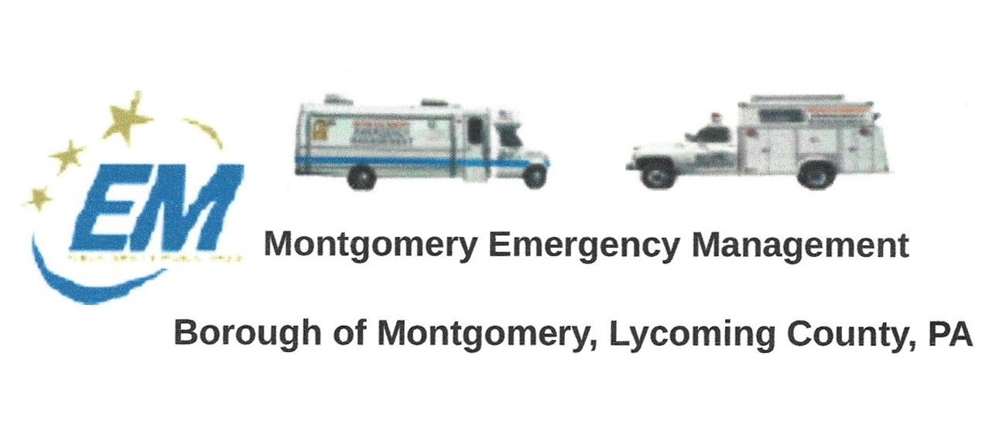
THE NEXT REGULAR MEETING OF THE MONTGOMERY BOROUGH EMERGENCY MANAGEMENT AGENCY WILL BE:
Greg Gruver, EMA Coordinator. 77 East Houston Avenue, Montgomery, PA 17752
Telephone: 570-547-1212 Cell: 570-419-4866 Email: monteman61@gmail.com
Fae Herb, Administrative Assistant. 102 Broad Street, Montgomery, PA 17752
Cell: 570-506-9892 Email: faeherb@aol.com
Meeting Room and Equipment Building: 40 Thomas Avenue, Montgomery, PA 17752
Borough EOC: 570-547-1671 Fire Hall EOC: 570-547-1380
INTERNET WEBSITE: www.montgomeryboroughema.org

THURSDAY, AUGUST 11, 2022 AT 7 P.M
REFRESHEMENTS WILL BE PROVIDED BY LES GRUVER
NOTES FROM ADMINISTRATIVE ASSISTANT, FAE HERB

The community showed up on Monday, July 25th to welcome WNEP-16 meteorologist Joe Snedeker as he rode his bicycle in on his “Go Joe” fundraiser for St. Josephs Center. Here in Montgomery we have our own “local meteorologist” who keeps us informed on social media of local storms, Les Gruver. We thank you for staying on top of it and sending us alerts….soon it will be snow storms !!!
The EMA continues their working relationship with the borough and fire company. Recently helping with transportation of fire hoses back to the firehall and use of the light tower for water breaks.
We are always interested in having new members join the EMA. Greg heads the EMA water rescue team and is always looking for people who may want to join. Recently a drowning occurred in the Susquehanna River, the borough and township abutting the Susquehanna its important to have trained personnel to assist.
We thank Dennis Gruver, Greg Gruver, Dale Brendle and Ed Ferguson who volunteered their time at the Lycoming County Fairgrounds. Assisting with weather reports and monitoring activities.
Upcoming events in September will be the Annual 9-11 Motorcycle Memorial Ride and also the Balloon Fest at Hughesville Fairgrounds.
If you are interested in becoming a member of the Montgomery Borough EMA, attend our meetings. We meet the Second Thursday of every month at 7 p.m. at 40 Thomas Avenue. Meeting Room is located behind the EMA garage.

